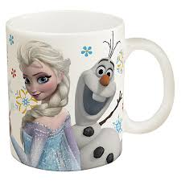

Perfect mug for frozen lovers…. Start your day with your favourite drink in these colourful classic mugs!

Product: Frozen Cartoon Mug

Price: 500 PKR

CONTACT US: Address: Aptech Metro StarGate Karachi

Email: feedback@aptech-education.com.pk